**Data Flow Diagram**

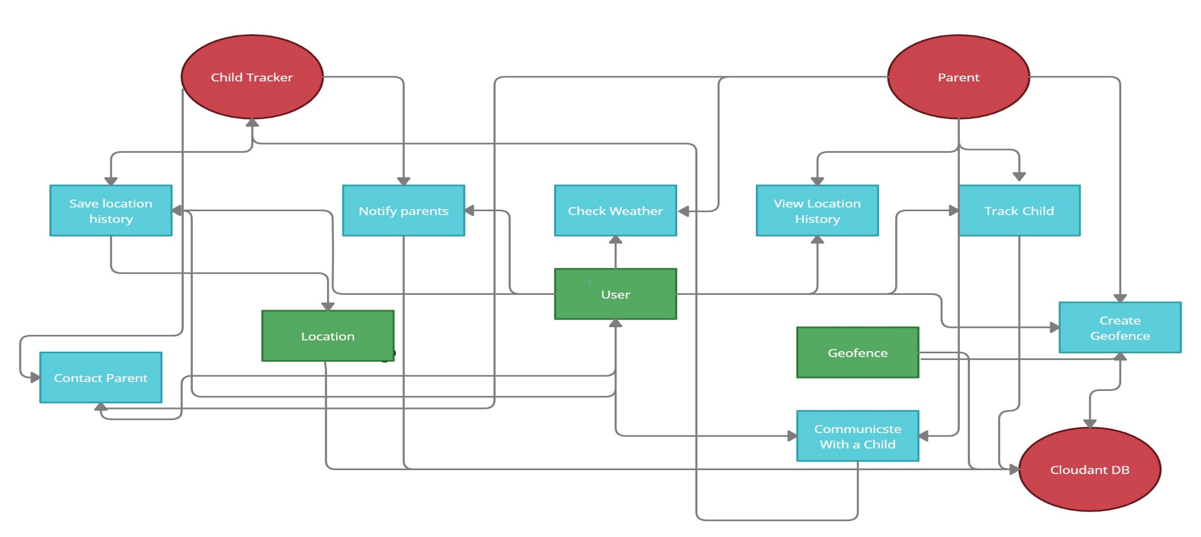Data Flow Diagram

**TEAM ID : PNT2022TMID12112**

**PROJECT NAME : IOT BASED SAFETY GADGET FOR CHILD SAFETY MONITORING AND NOTIFICATION**